I
How your property
tax bill is calculated

How your property tax bill is calculated

In Texas property tax bills are determined by two numbers: 1) Your In Texas property tax bills are determined by two numbers: 1) Your
property’s value and 2) the tax rates for each of the taxing entities where property’s value and 2) the tax rates for each of the taxing entities where
your property is located (city, county, school district, special districts, etc.) your property is located (city, county, school district, special districts, etc.)
FIND YOUR PROPERTY VALUE FIND YOUR PROPERTY VALUE 
Properties are appraised annually as of January 1 by the county Properties are appraised annually as of January 1 by the county
Appraisal district, so your appraised value can change every year Appraisal district, so your appraised value can change every year
depending on sales in the county. depending on sales in the county.


TOTAL YOUR TAX RATES TOTAL YOUR TAX RATES
COUNTY $_____

SCHOOL $_____

CITY $_____

SPECIAL $_____
DISTRICTS

COUNTY $_____

SCHOOL $_____

CITY $_____

SPECIAL $_____
DISTRICTS

Texas doesn’t have a state property tax – property taxes are only Texas doesn’t have a state property tax – property taxes are only
Collected by local entities. Collected by local entities.

MULTIPLY YOUR PROPERTY VALUE MULTIPLY YOUR PROPERTY VALUE

BY YOUR TOTAL TAX RATE BY YOUR TOTAL TAX RATE
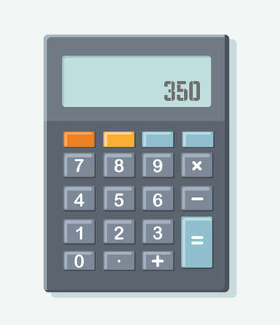


1.74
1.74
PROPERTY TAX BILL
PROPERTY TAX BILL

For example, a with a ……. has a For example, a with a ……. has a
$200,000 X $1.74 ÷ 100 = $3,480 $200,000 X $1.74 ÷ 100 = $3,480
property (multiply) tax rate tax bill property (multiply) tax rate tax bill

